**DSP – Experiment 15**

**Anti-Aliasing Filter**

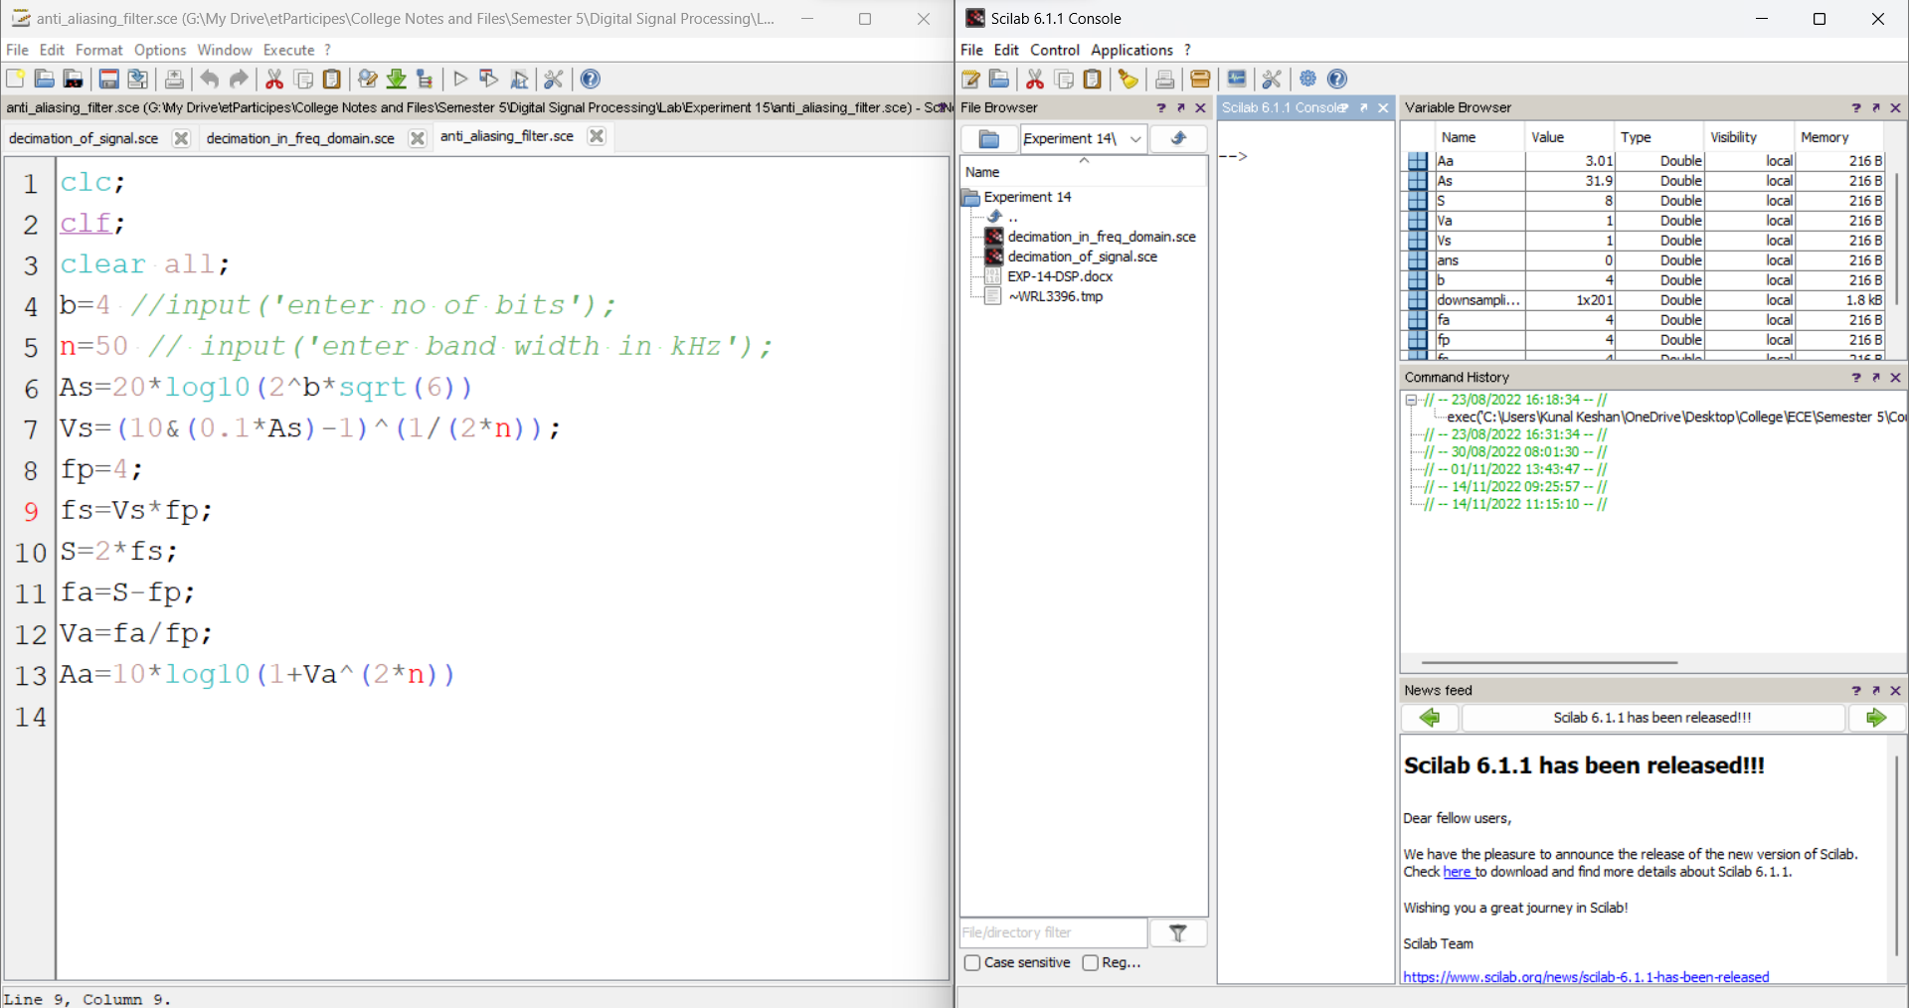

**Anti-Imaging Filter**

